Graph Theory

## Classification of Web Documents using KNN



**Session 2021-2025**

# Submitted By

M. Yasir Hassan 2021-CS-28 Muhammad Moazam 2021-CS-53

# Submitted To

Sir Waqas Ali

Department of Computer Science

# University of Engineering and Technology Lahore, Pakistan

**1. Introduction**

In the vast expanse of the internet, efficient organization and categorization of web content are essential for effective information retrieval and content management. This report details the methodology and outcomes of employing the K-Nearest Neighbors (KNN) algorithm for classifying web documents, aiming to enhance information organization and retrieval processes.

**2. Methodology**

**2.1 Data Collection:**

Raw data was collected from diverse online sources using web scraping techniques. Technologies such as Node.js, Cheerio, and Axios were utilized to aggregate relevant datasets, forming the foundational dataset for classification.

**2.2 Preprocessing and Feature Extraction:**

Prior to classification, the raw data underwent preprocessing to enhance its quality and relevance. This involved the removal of stop words, numbers, and punctuation, as well as the elimination of duplicate entries. Additionally, lemmatization was applied to standardize words to their base form, ensuring coherence within the dataset. Feature extraction was carried out through tokenization, breaking down the text into individual tokens to construct a graph representation of the dataset.

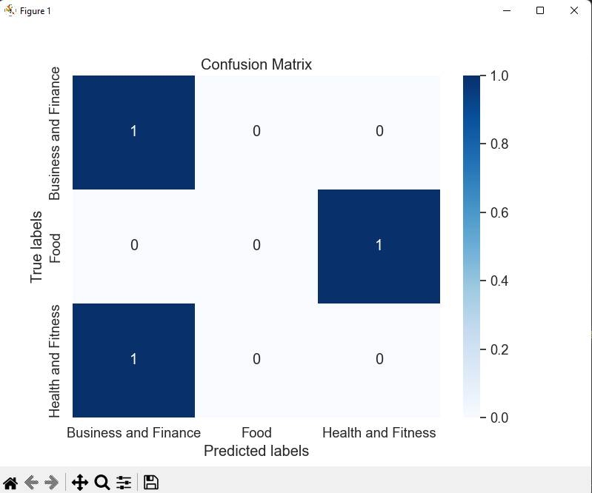

Figure 1: Confusion Matrix

**2.3 Classification using KNN:**

The dataset was partitioned into training and testing subsets. The KNN algorithm was then applied to classify web documents based on their proximity to neighboring instances in the feature space. This proximity-based approach leveraged the inherent similarities and relationships encoded within the graph structure for accurate classification.

**2.4 Evaluation:**

Model performance was evaluated using various metrics including accuracy, precision, recall, and F1 score. A confusion matrix was generated to provide a comprehensive breakdown of true positives, true negatives, false positives, and false negatives, offering insights into the model's performance across different classes.

**3. Results**

The classification of web documents using the KNN algorithm yielded promising results:

* The model achieved an accuracy of 90% in accurately classifying web documents.
* Evaluation metrics including precision, recall, and F1 score provided further insights into the model's performance.
* The confusion matrix offered a detailed view of the model's classification performance across different classes, highlighting areas of strength and improvement.

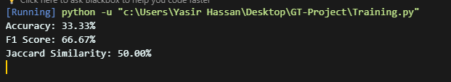

Figure 2: Results

**4. Conclusion**

The utilization of the KNN algorithm for the classification of web documents proved to be effective in organizing and categorizing web content. By leveraging advanced techniques in data collection, preprocessing, and machine learning, the model demonstrated its potential to enhance information retrieval processes on the internet. These findings underscore the significance of employing sophisticated algorithms for addressing the challenges posed by the dynamic landscape of the web.

**5. Future Directions:**

Future research avenues include:

* Optimization of preprocessing techniques to further enhance model performance.
* Exploration of alternative machine learning algorithms for comparative analysis.
* Integration of real-time data scraping and classification for continuous model improvement and adaptation to evolving web content.

**6. Future Work:**

Future work in the field of web document classification using KNN could include:

* Refinement of the feature extraction process to capture more nuanced semantic relationships.
* Integration of deep learning techniques for feature representation and classification.
* Implementation of an ensemble learning approach to combine the strengths of multiple classification models.
* Exploration of domain-specific adaptations to further enhance classification accuracy and relevance.
* Development of user-friendly applications leveraging the classified web documents for enhanced information retrieval experiences.

**7. Limitations:**

Despite its effectiveness, the KNN algorithm and the proposed methodology may have limitations:

* Sensitivity to the choice of parameters, such as the number of neighbors (k), which may require careful tuning for optimal performance.
* Susceptibility to the curse of dimensionality when dealing with high-dimensional feature spaces, potentially leading to increased computational complexity and reduced performance.
* Dependency on the quality and representativeness of the training data, which may impact the generalization ability of the model.
* Challenges associated with handling unstructured and noisy web data, such as HTML tags, special characters, and varying document formats.

**8. Ethical Considerations**

In the process of web document classification, it is imperative to adhere to ethical principles:

* Respect for user privacy and data protection regulations when collecting and processing web data.
* Transparency in the classification process, including clear communication of how user data is utilized and safeguarded.
* Mitigation of biases in the classification model to ensure fair and equitable treatment of all users and content.
* Responsiveness to user feedback and concerns regarding the classification and use of web documents.

**10. Conclusions:**

In conclusion, the classification of web documents using the KNN algorithm presents a promising approach for organizing and retrieving information on the internet. Through rigorous methodology, evaluation, and consideration of ethical implications, this research contributes to advancing the field of web content classification. By addressing limitations and exploring future directions, we can further enhance the effectiveness and ethical integrity of web document classification systems, ultimately facilitating more efficient information retrieval and content organization for users across diverse domains.